Six Can Competition
(rule version v20190119.00)

Objective: Six empty fluorescent orange colored soda cans are placed in a walled playing field that resembles a soccer field. Each end of the field will have a goal and a starting area. The challenge is to collect the cans and place them in the opposing goal as quickly as possible. A judge decides the location of the cans.

Robot: Competing robots must run autonomously but are not required to be self-contained. Robot size is limited to less than 18x18 inches at the start of the competition. The robot may extend to a single footprint size of 21x18 inches, after moving outside the starting/goal area. These dimensions are chosen specifically to give competitors flexibility in the design of their robot base, and to specificity allow the use of iRobot Create/Roomba and Vex Clawbot type robots. Maximum robot weight is 20 pounds.

Self-Contained Definition: Self-contained means that all computing power used to run the robot is carried on the robot platform.

Run Definition: A run starts when the robot is placed in the start area of the arena, given a signal from the judge, and moves. If the robot fails to move, the competitor can remove the robot and try again at the end of the round. If the robot doesn’t move when given this 2nd chance, its run is forfeited. The run ends when all 6 cans are placed in the opposing goal, or the time limit is reached or the robot malfunctions or the robot appears hopelessly lost or trapped. The time limit for a run is 5 minutes. Each robot is allowed 1 run per contest round.

Round Definition: A round consists of a single run by each competing robot. The competition consists of 3 rounds.

Play: At the start of the competition, the robot's owner may place the robot anywhere in a start area. The robot may be turned to any angle when initially placed. Robots must fit in the starting area which is bounded by blue tape on 3 sides and the goal plane on the remaining side. This area is 18”x35”. The robot can be started at either of the goals.

A robot may only have control of one can at a time. Control is defined as changing the location of a can in a directed direction. An example of “control” would be a can in the robot’s gripper. An example of a can movement that is not in “control” would be a robot nudging a can, but then moving off. Changing a can location with an air stream or a kick or a projectile is considered
“controlling” the can.

If a robot is controlling more than one can at a time, the judge will immediately remove the additional cans from control and place them in a location of his choice. If a force causes multiple cans to be controlled, all controlled cans but one will be returned to a position of the judge’s decision.

Competitors can setup beacons or other navigational aids outside of the walled area along the longer sides of the field, but not in the shorter side of the field or the area near or at the goals.
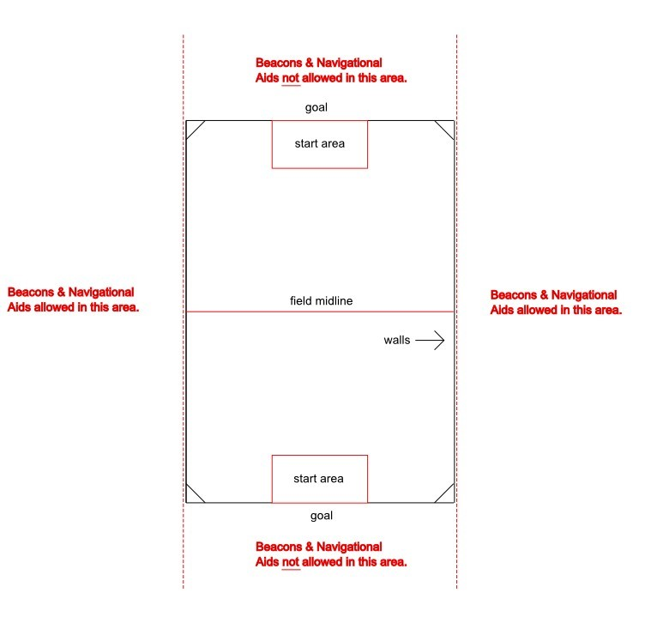

Course: The course size is 7x10 feet. The course surface will be the flooring of the room used for the competition, or such temporary material as is needed to protect that floor as deemed necessary by contest organizers and venue operators. This material could include wood, Tyvek, low-pile carpet, dense foam or other common flooring materials. The outline of the course will have walls of approximately 8 inches in height except where the goals are located. The color of the walls is white. The goals will be 35 inches wide and have a crossbar located at a height of 12 inches. The starting area is in front of the goal extending 18 inches into the field. It will be outlined with ¾ inch blue painter tape. Blue painter tape may also be used to mark the middle of the field but is not required. The course may also have a short wall at the corners of the arena as shown in the arena diagram, but typically these corner walls are not used, and the corners are left square.

Six Can Arena Diagram
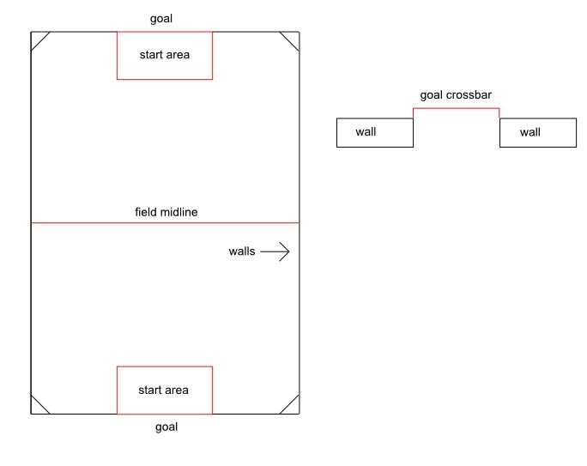
Can Specifications: The cans used in this contest are empty standard 12-ounce aluminum soda cans wrapped in 1 or 2 layers of fluorescent orange duct tape. The tape used is Duck Brand Model #1265019 Neon Colored duct tape. It is available at Walmart, Home Depot, Staples and Amazon. The pull tabs may or may not be removed.

Can Placement: The judge will select locations for the cans just before the contest. These locations will be marked with a small piece of blue painter tape, so that all competitors have the same field. No robot may enter the course once the can locations are selected except to compete. This is to prevent pre-event mapping of the can locations. Cans locations must be at least 5 inches from the walls of the arena. The judge may alter the can locations between each round of the competition.

Scoring: A robot’s run score is the sum of the number of cans placed in the opposing goal (scored) within the time limit. The top three scores will be awarded 1st, 2nd, and 3rd place in the competition. If multiple perfect scores are achieved, the fastest run time will be used to determine the winner. If no perfect score is achieved and there is a tie in the number of cans scored, the tied contestants will all make an additional run to score a single can. The judge will place a single can in the arena for this run. The robot that scores in the shortest time gets the highest placement. The other robots will be ranked on the speed that they score. If some or all robots fail to score the can, they will determine their rank between themselves by coin toss. Time limit for this run is 3 minutes. No place or prize will be awarded to a robot that doesn’t at least score one can during the competition.

A perfect score is 6.

Judging: One or more judges will referee the contest. They will ensure the rules are followed and impose scoring penalties or remove a robot from competition if the robot is operating in an unsafe manner or not complying with the rules. The decisions of the judges are final.

Safety: If the behavior of a robot is determined to be unsafe, the judge will withdraw the robot from the competition. Since pushing or “launching” cans is a legitimate strategy, the robot builder must take responsibility for limiting this ability so as not to create a safety hazard. The decisions of the judges regarding safety matters are final.

Picture of Six Can Arena
